T-Junction Sensitivity withing Grossberg's FACADE Model

Here, the defining quality of T-junction sensitivity is the ability to separate a T-junction's top from its stem, creating an “end-gap”. Involves feedback between horizontal bipole cells and vertical hyper-complex cells. Horizontal cells receive more signal input at a T-junction than in the vertical direction. The two types of cells have a cross-orientation inhibiting relationship with each other in proportion to their individual magnitudes. The increased horizontal cell response has the effect of inhibiting the vertical cells. This cross-orientation inhibition, caused by the presence of a T-junction, creates an end-gap.

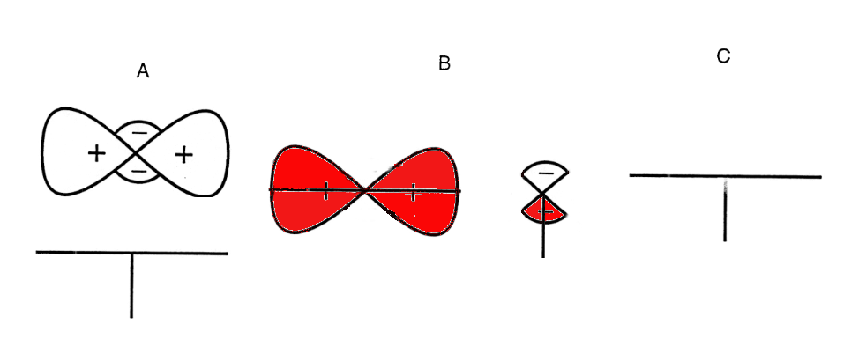Illustration 1: A: top oriented filters, below T junction image. B: responses of oriented filters. C: output of filter responses, with inhibited end-gap between stem and top.

This cross-orientation feedback system is call the Static-Oriented Cooperative-Competitive Feedback circuit (SOCC). The output of bipole cells is competed with that of the hyper-complex cell for the most likely spatial location of a boundary. This competition has the effect of sharpening output image [1], but it relativity difficult to tease apart individual functionality of the components given the model's highly developed state.

Mathematical description of Vertical, Hyper-complex cells

Role: Spatial competition – end stopping
On-center Off-surround network with excitatory and inhibitory shunting feedback routes from bipolar cells. Combines the summed output of various Gaussian filtered complex cell signals with filtered bipolar cell signals, with additional constants and ratio terms.
The interaction between positive feedback from ISO-oriented bipole cells and negative feedback suppressing weaker boundaries is the source of T-junction breaking.

Role: Orientational competition
FIDO activities produce by oriented filters are summed with response to inhibitory feedback term and combined with output of spatial competition output signal convolved with Gaussian filters.

Mathematical description of Horizontal Bipolar cells

Role: Boundary grouping – collecting oriented receptive fields
Process of boundary completion via iso-orientation grouping.

References:
[1] http://cns.bu.edu/Profiles/Grossberg/Gro1997PsyRev.pdf Original description (section 16)

[2]http://www.cns.bu.edu/Profiles/Grossberg/KelGro2000.pdf Mathematical functions of cells

[3] http://www.cns.bu.edu/Profiles/Grossberg/KelGro2000p.pdf 2000 Grossberg & Kelly paper

